**Openshift Container Platform**

1. Open your Redhat console and login with your credentials

<https://console.redhat.com/>

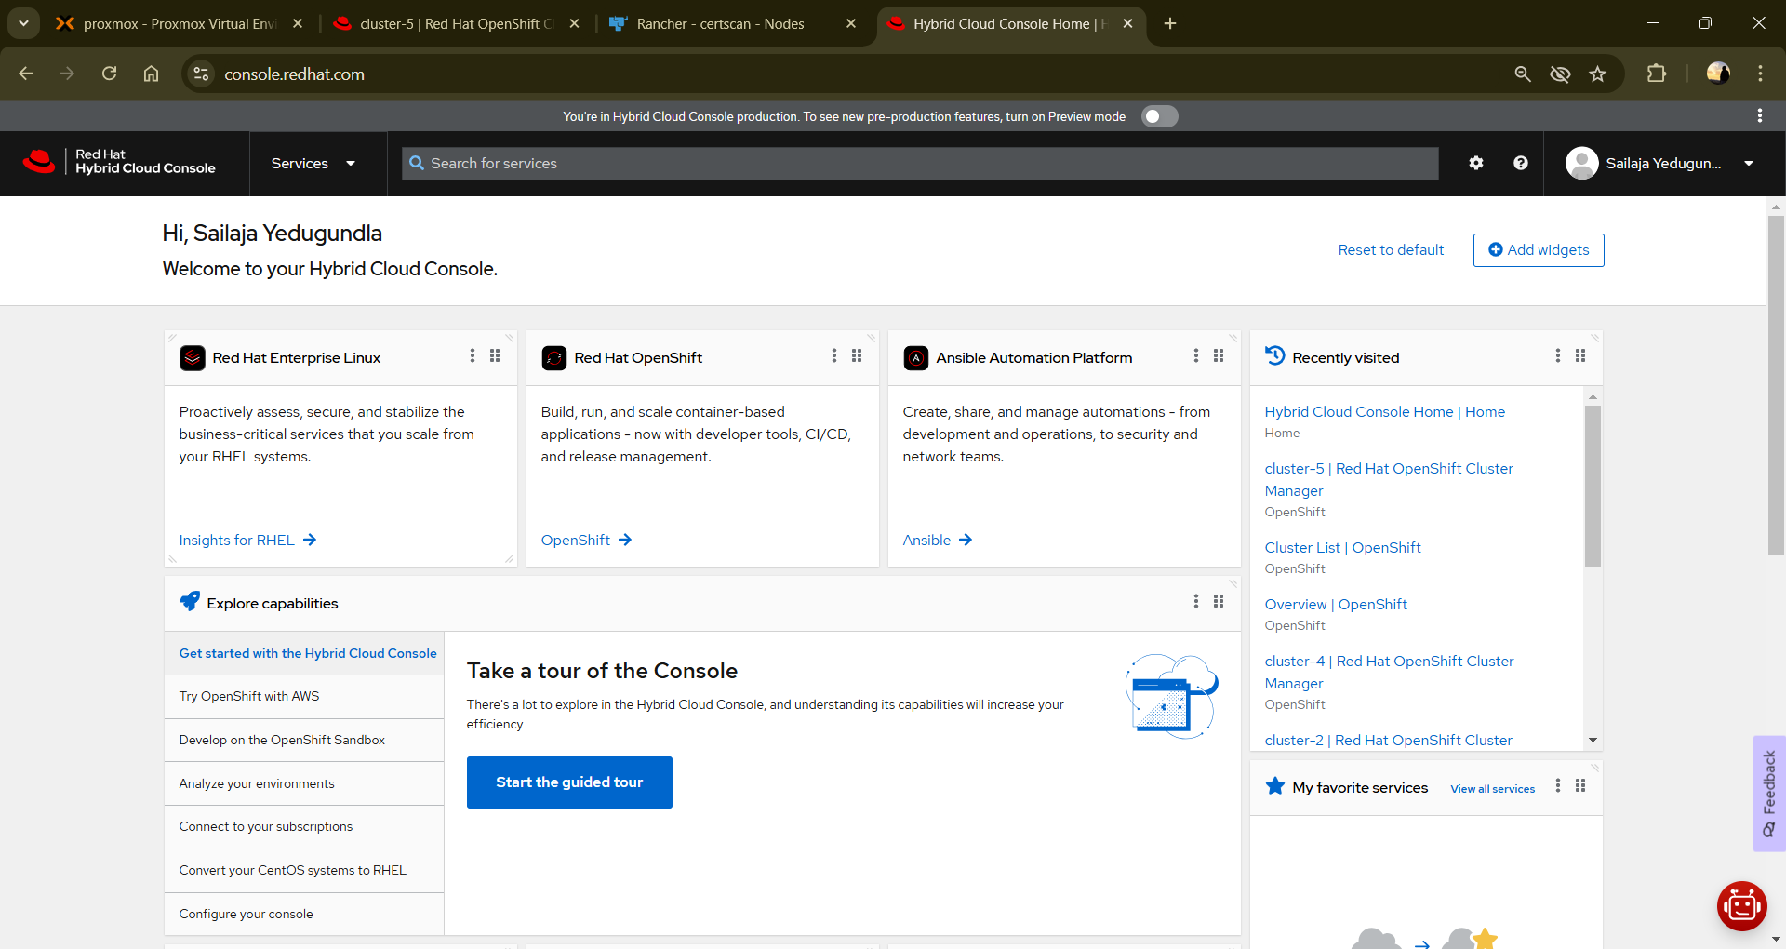

Then click on “Services” in the Top left corner

Now, Choose “Red Hat Openshift” from the options on the left side of the page

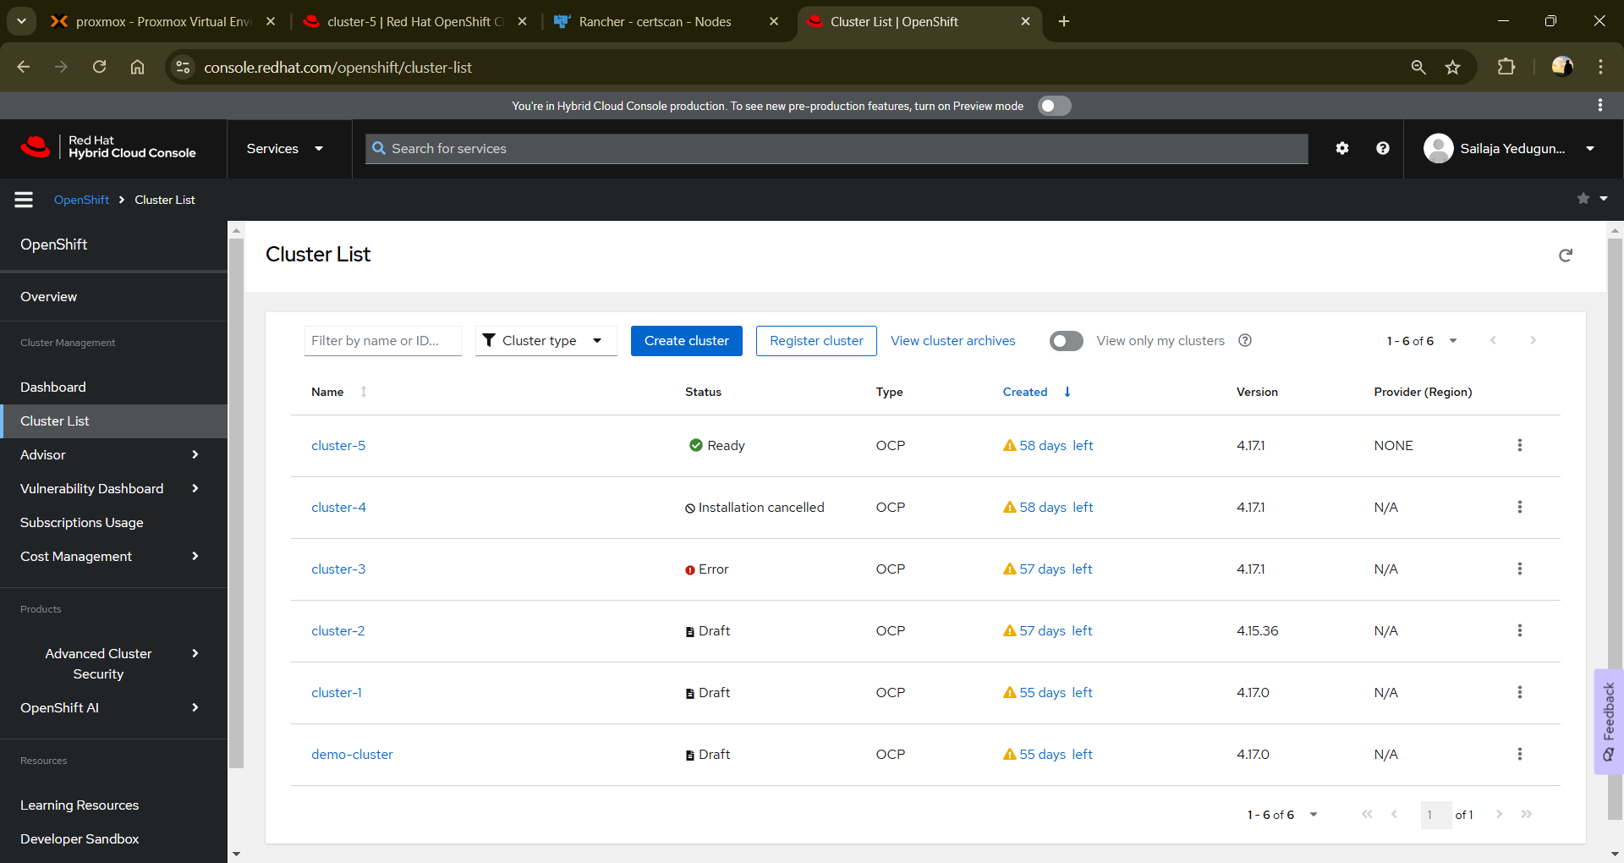

Go to “Cluster List” and there you can create a new cluster. Click on “Create Cluster” option.

Choose “Datacenter” option from the above available options. Click on “Create Cluster” option.

Enter the required details like “Cluster Name”, Give a domain name and choose computer(VM) architecture and you can either go with High Availability option where in you will have 3 control plane. For now, I am going with SNO (single node OpenShift). Keep the network configuration as DHCP only.

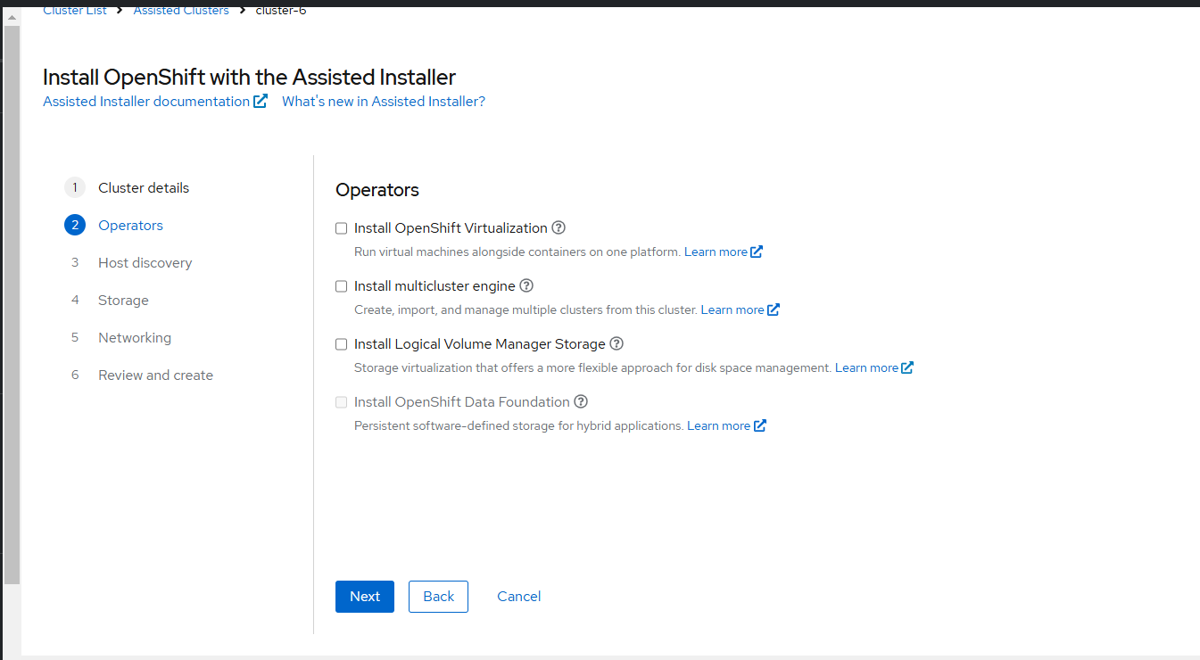

Skip this operators part and go to next page.

Here, click on the “Add Host” button where you need to give a public key to generate discovery iso file that is used to initialize the nodes(master nodes) for the Openshift container platform. The private key corresponding to the public key that you have given in this step is used to SSH into the control plane nodes in the future. For now, I have copied public key from a VM from which I am going to access these nodes in the future.

Click on “Generate Discovery ISO” button.

Download the Discovery ISO file and use it to boot your application. Use this Discovery ISO file as OS for your new VM. Start the VM and it will automatically run the preconfigured script and connect it the Openshift cluster, which you can see here.

If these nodes have sufficient amount of RAM and CPU cores then it will show you in “Available” state. RAM should have a minimum of 16GB. The more you give the better it is (Cores and RAM).

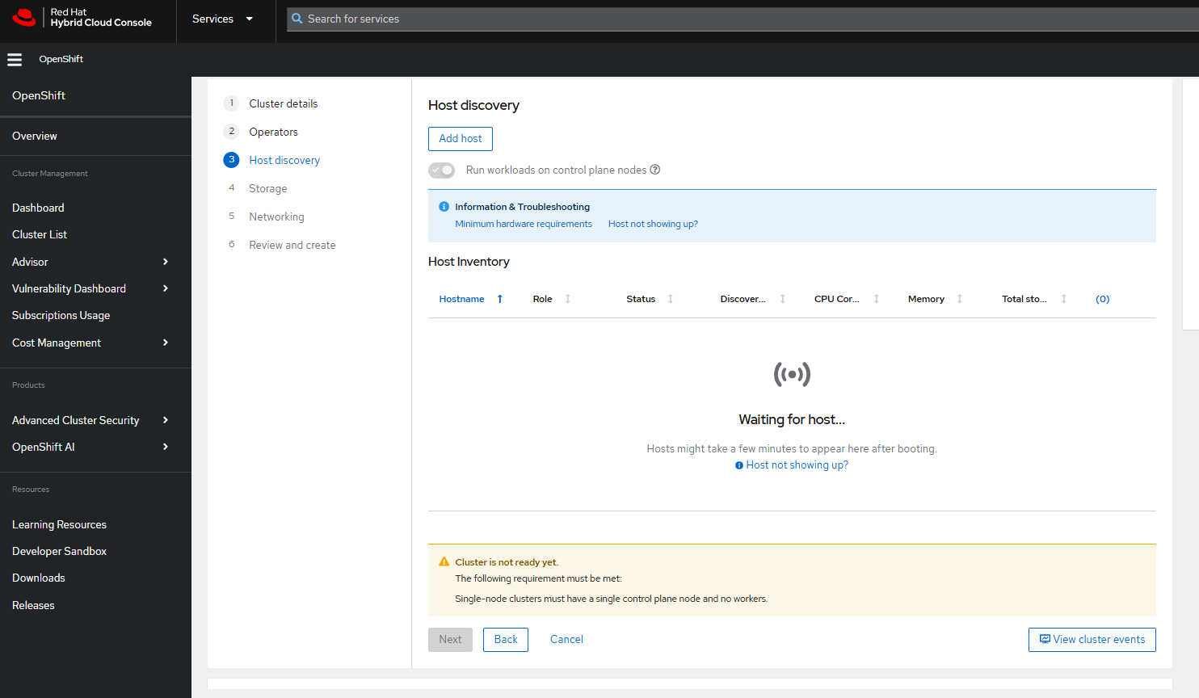

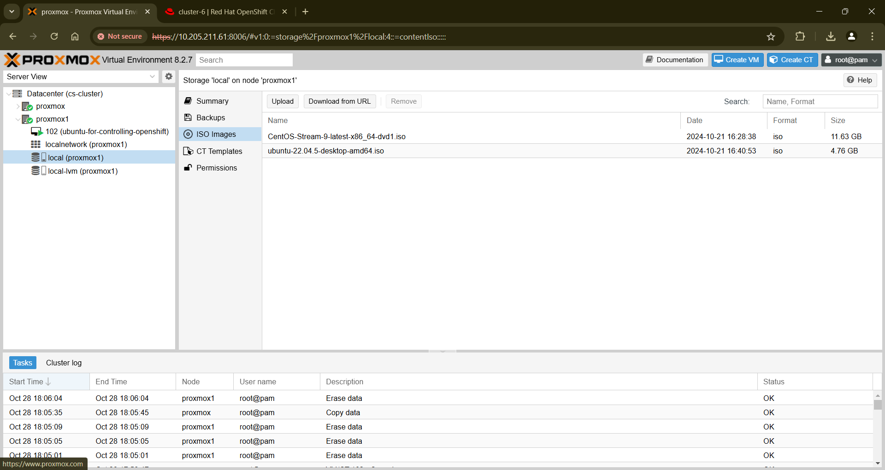

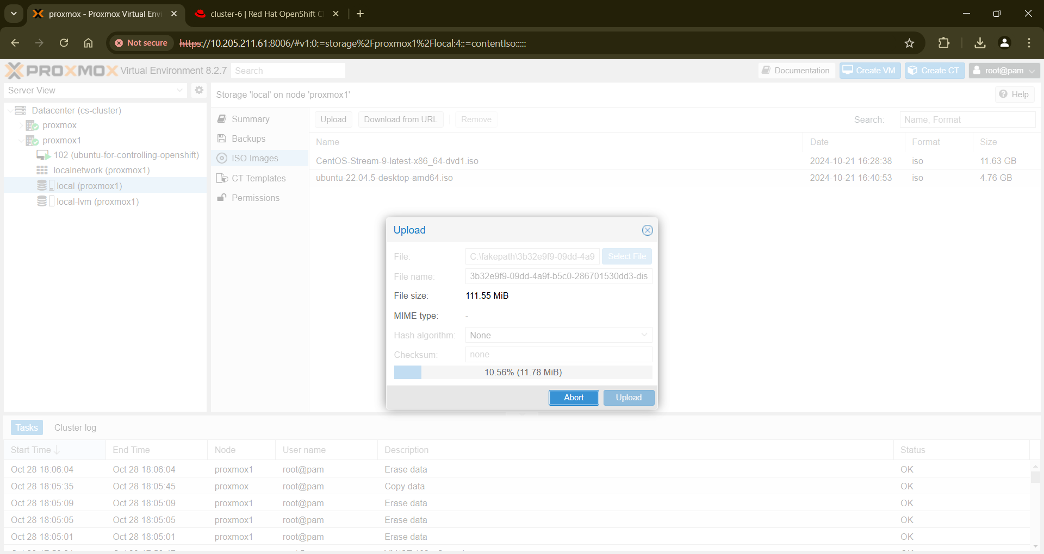

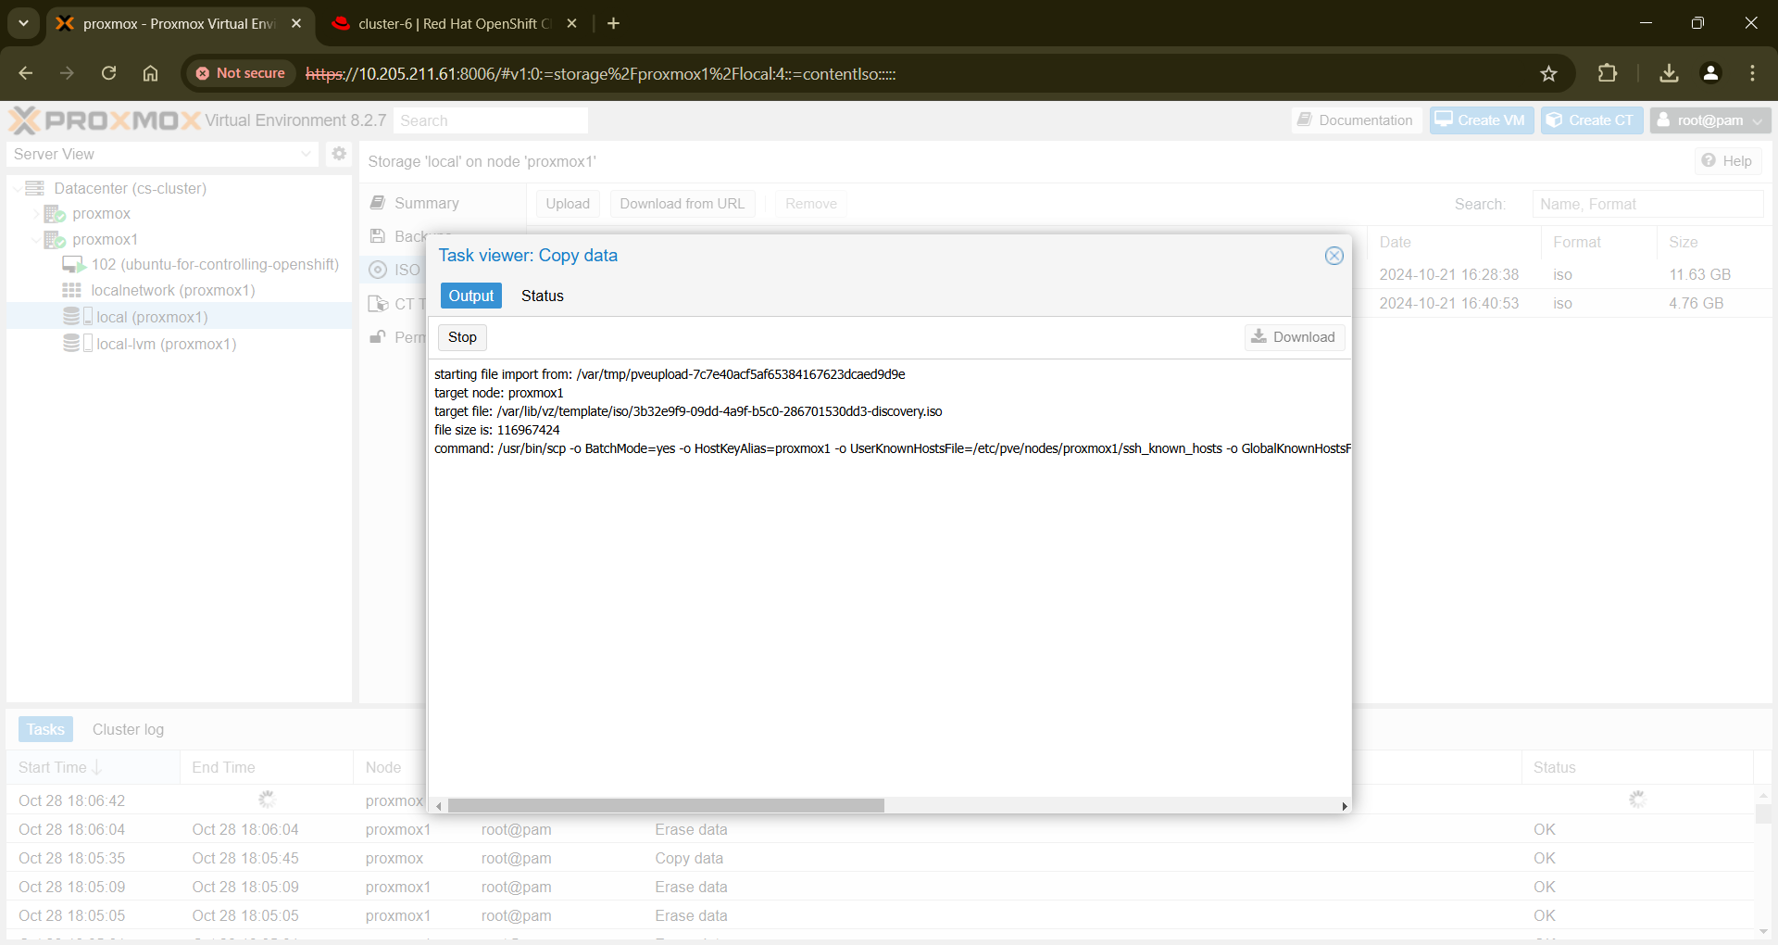

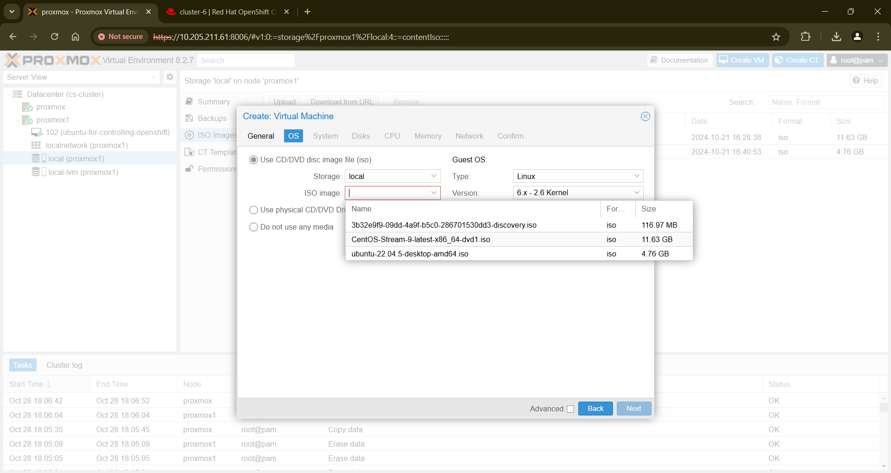

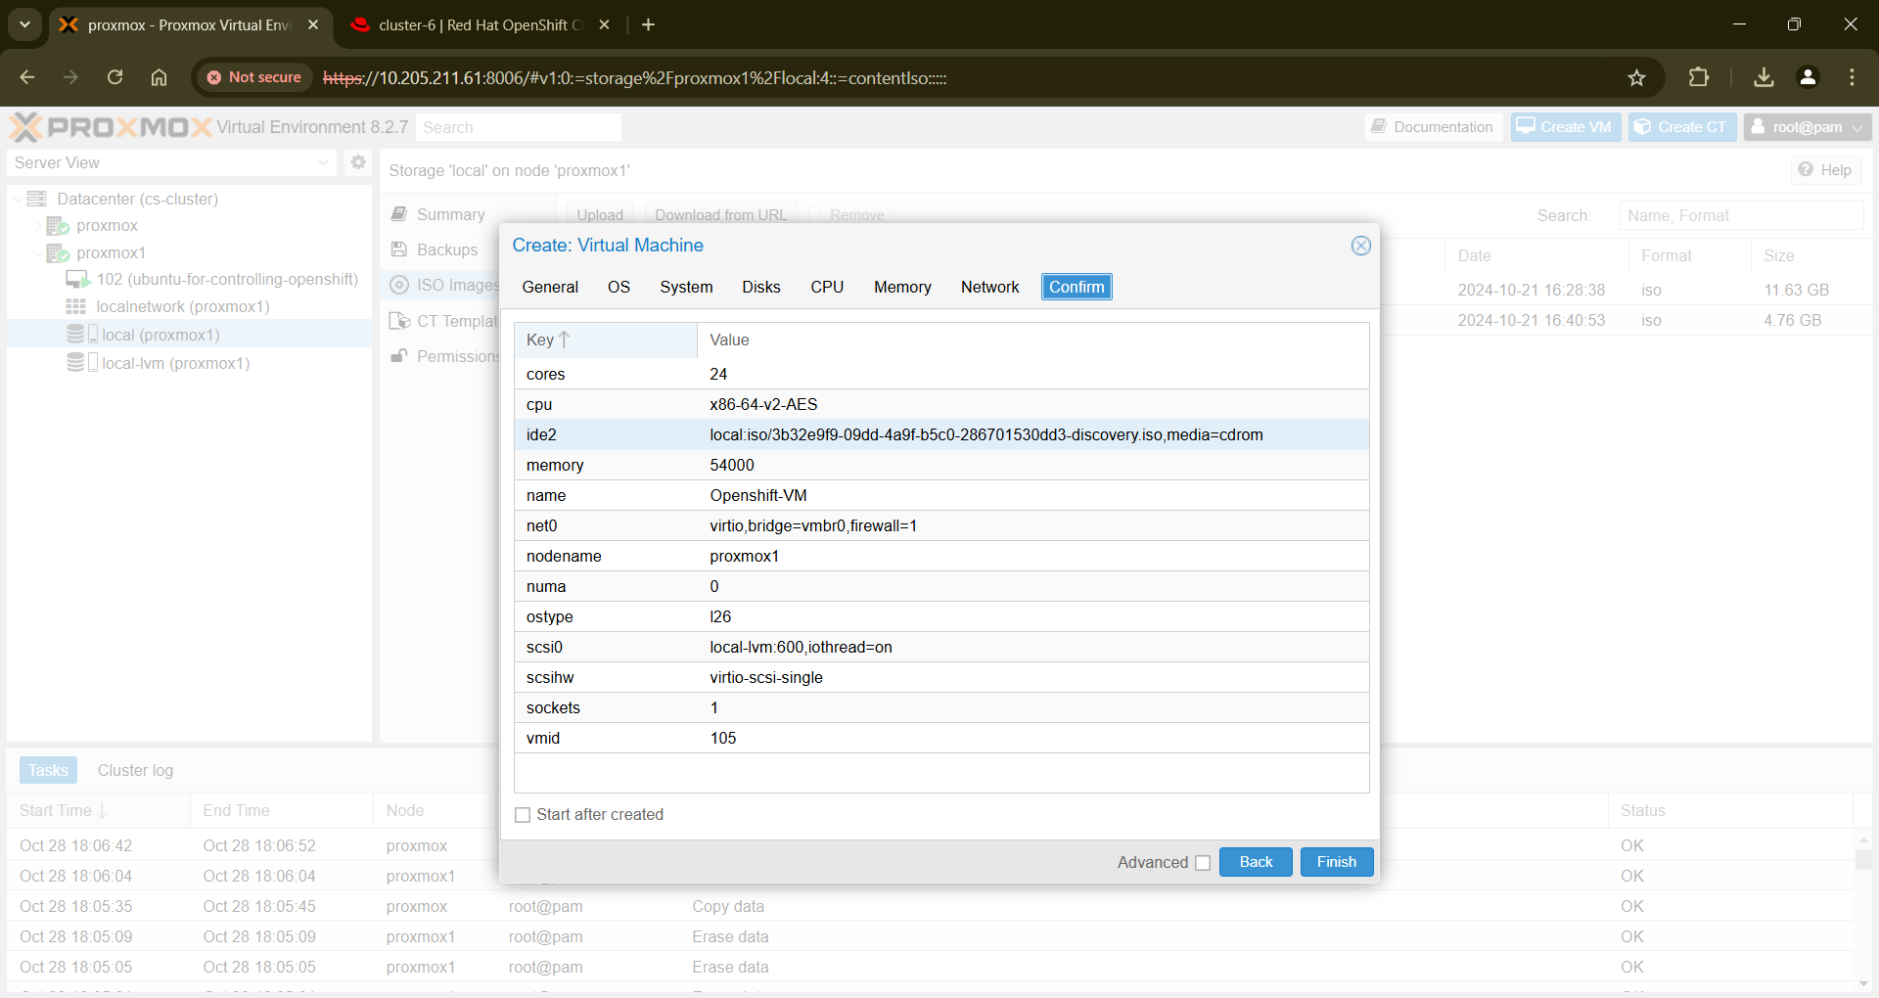

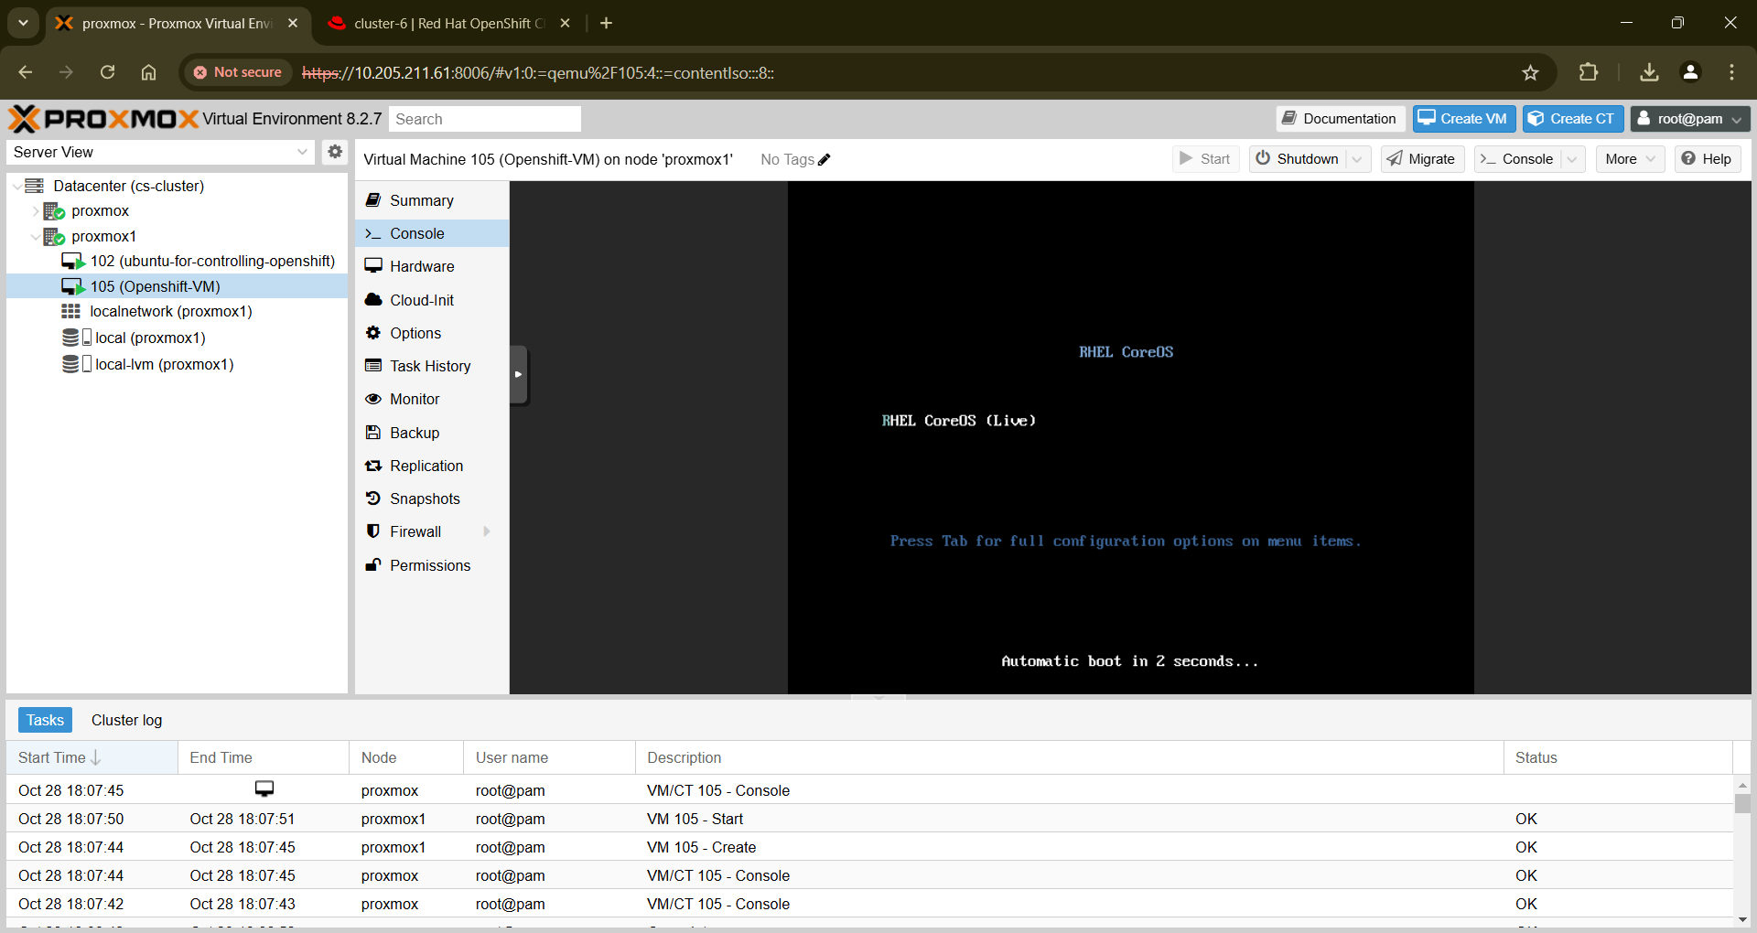

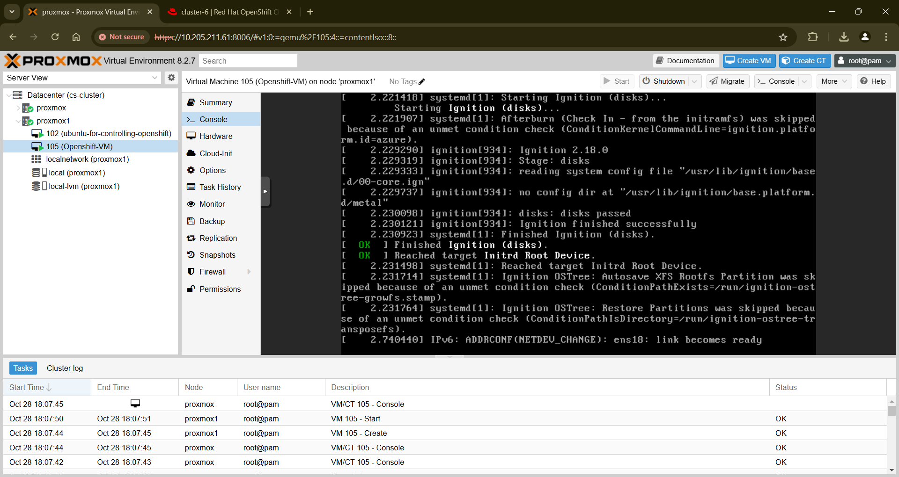

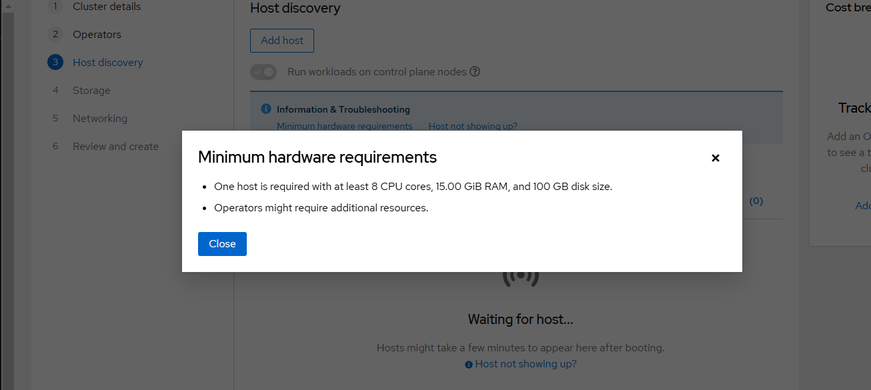

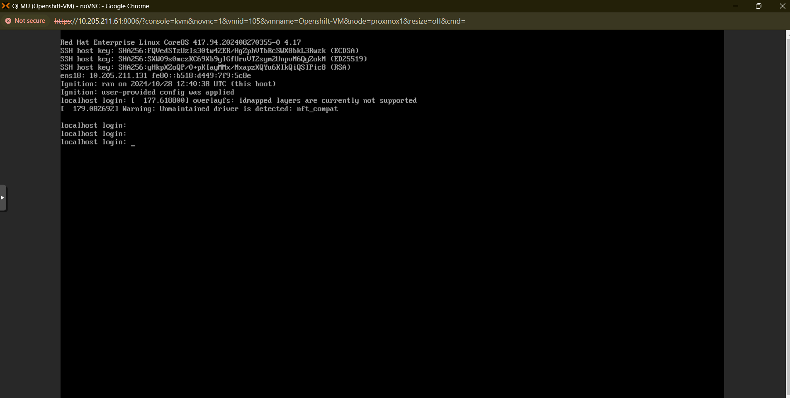

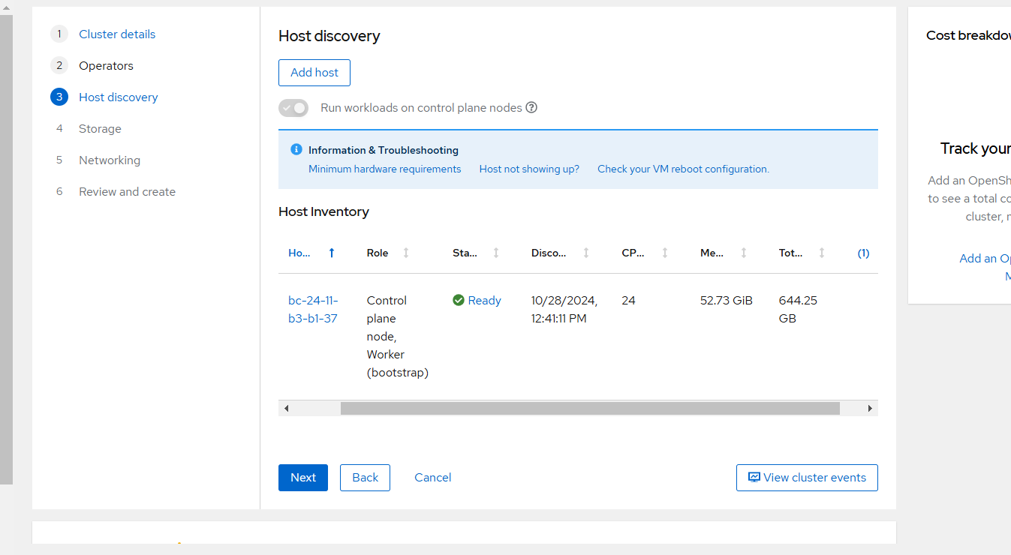

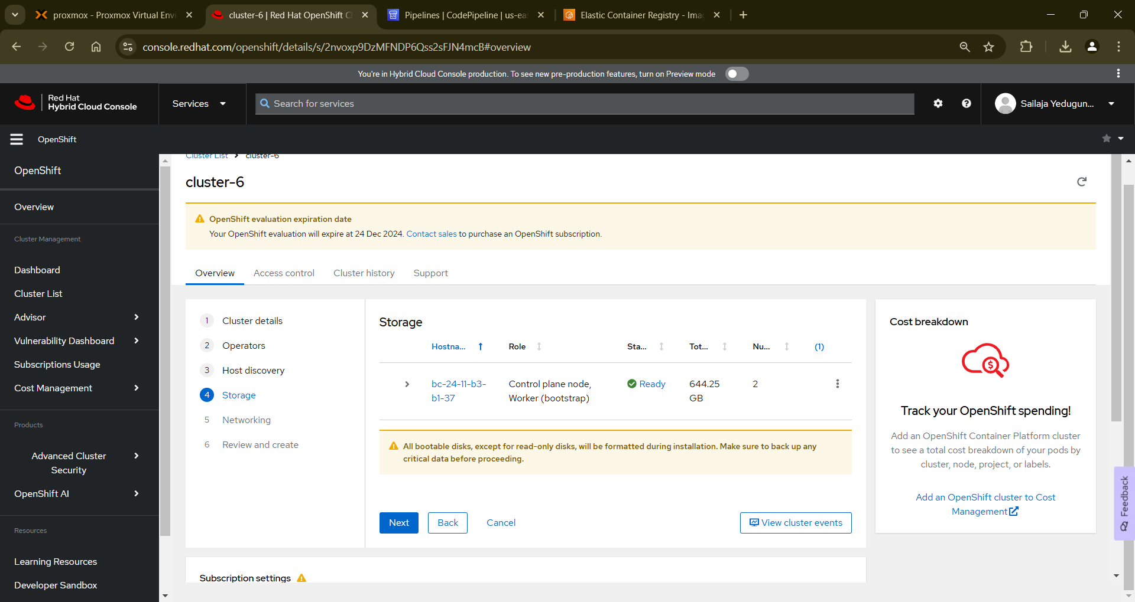

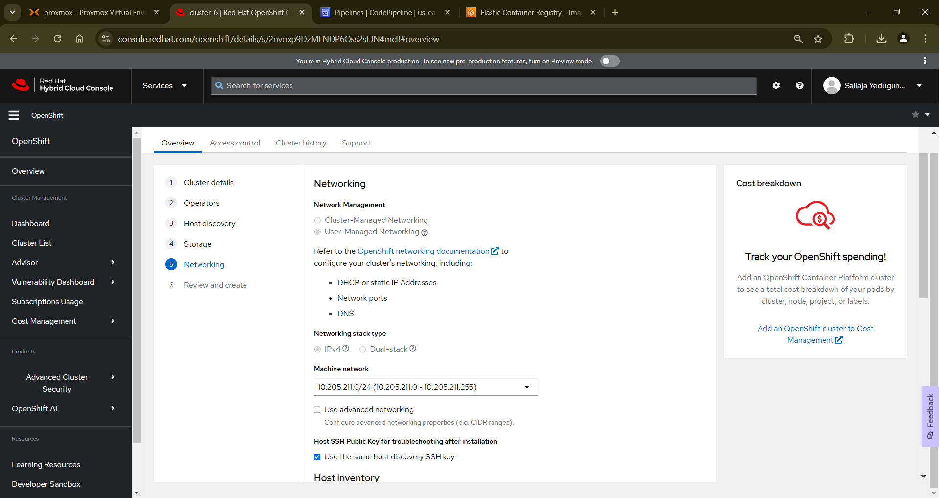

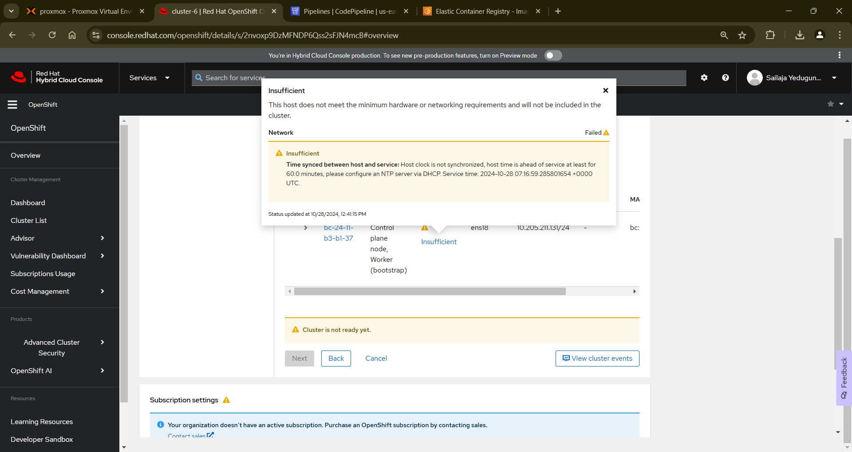

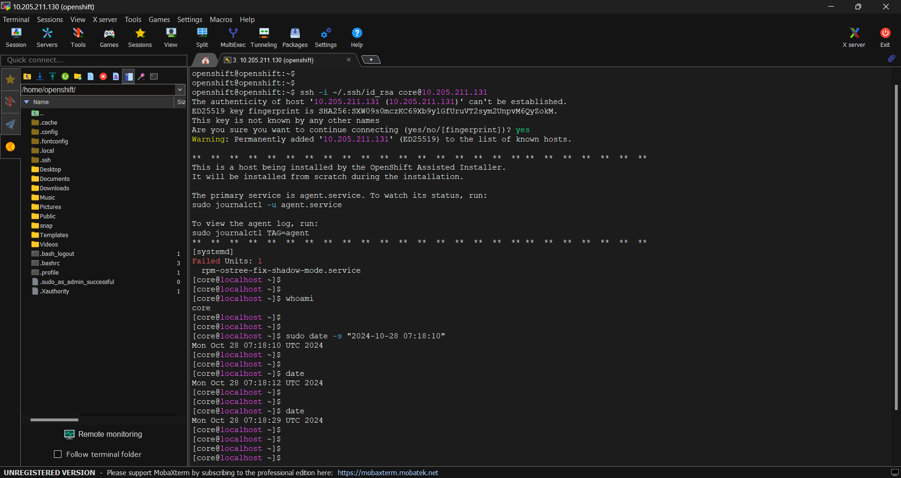

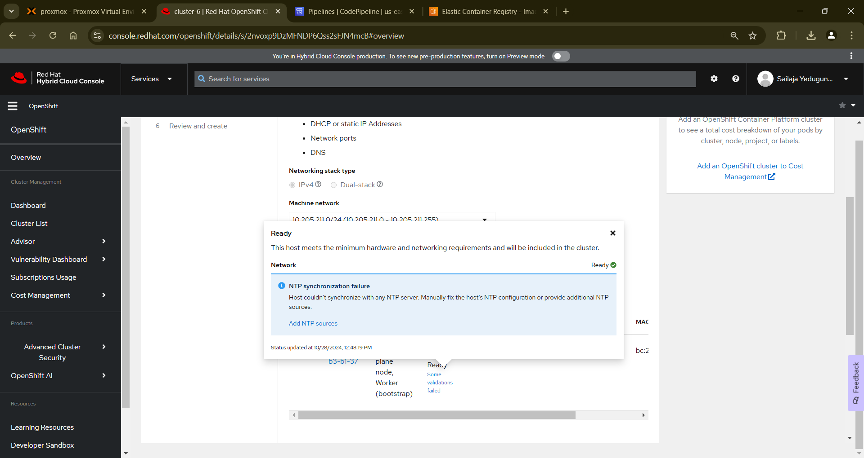

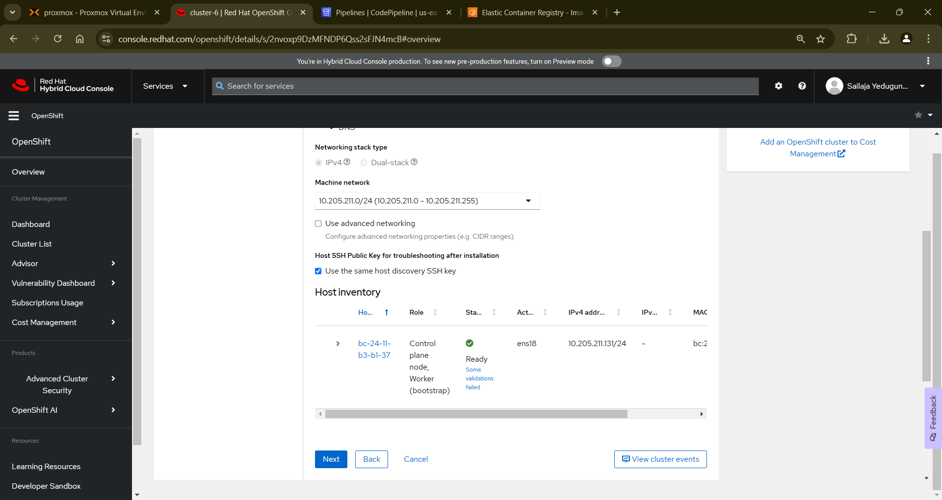

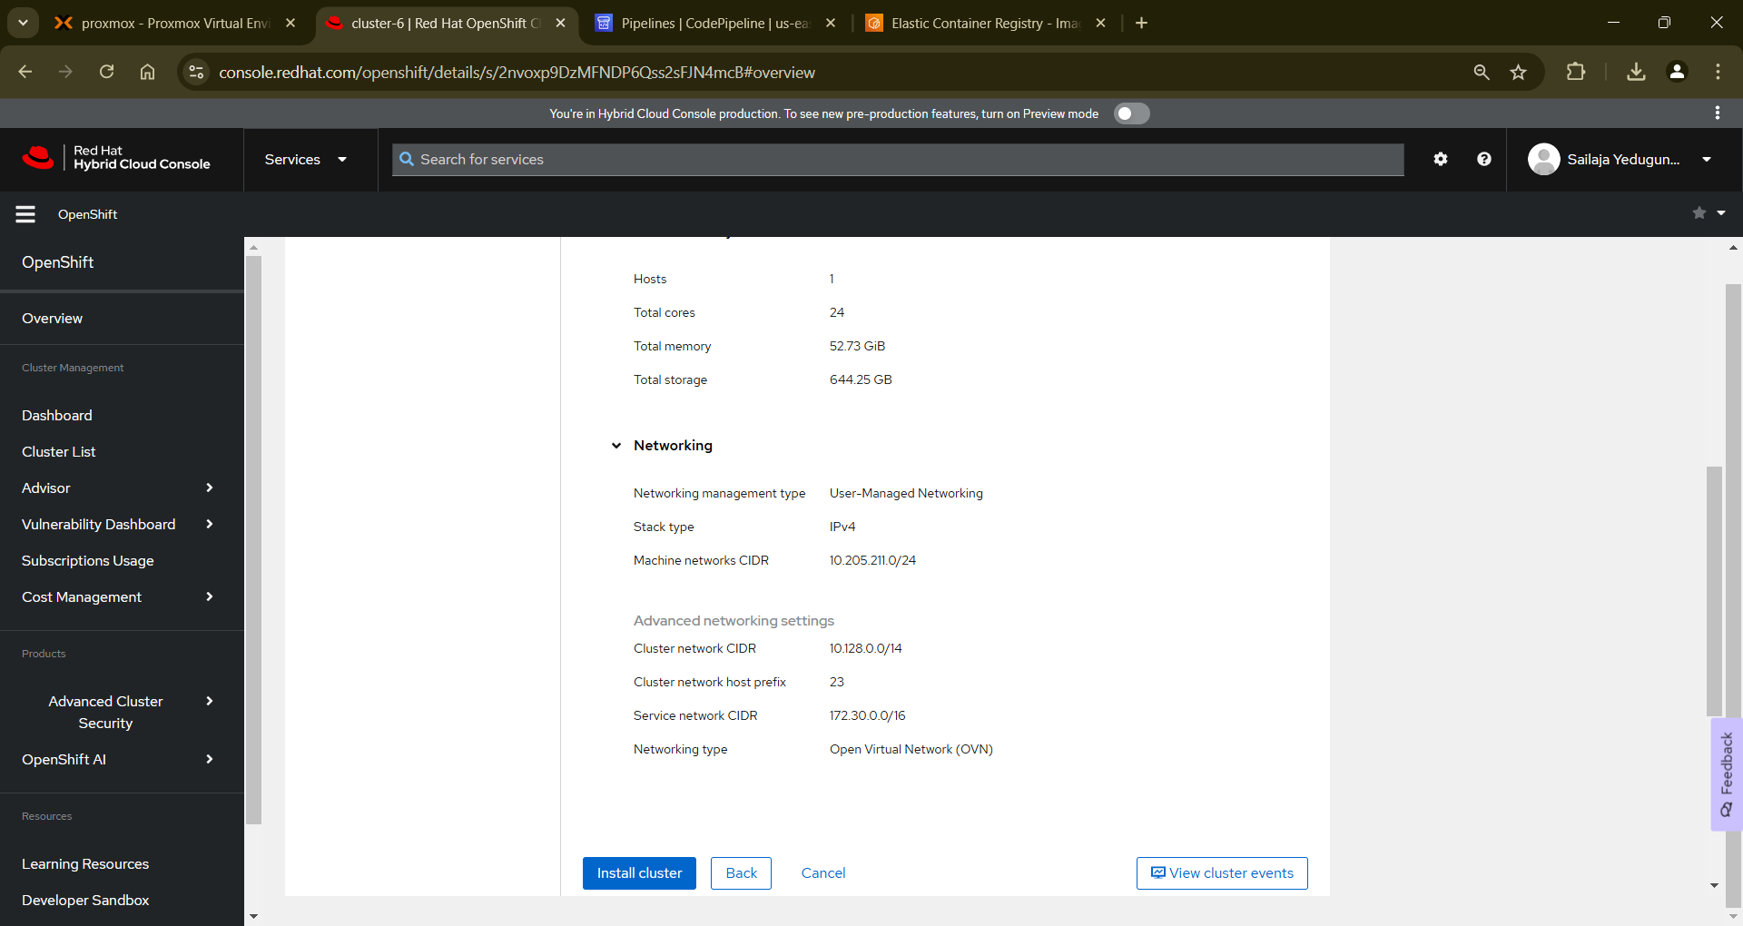

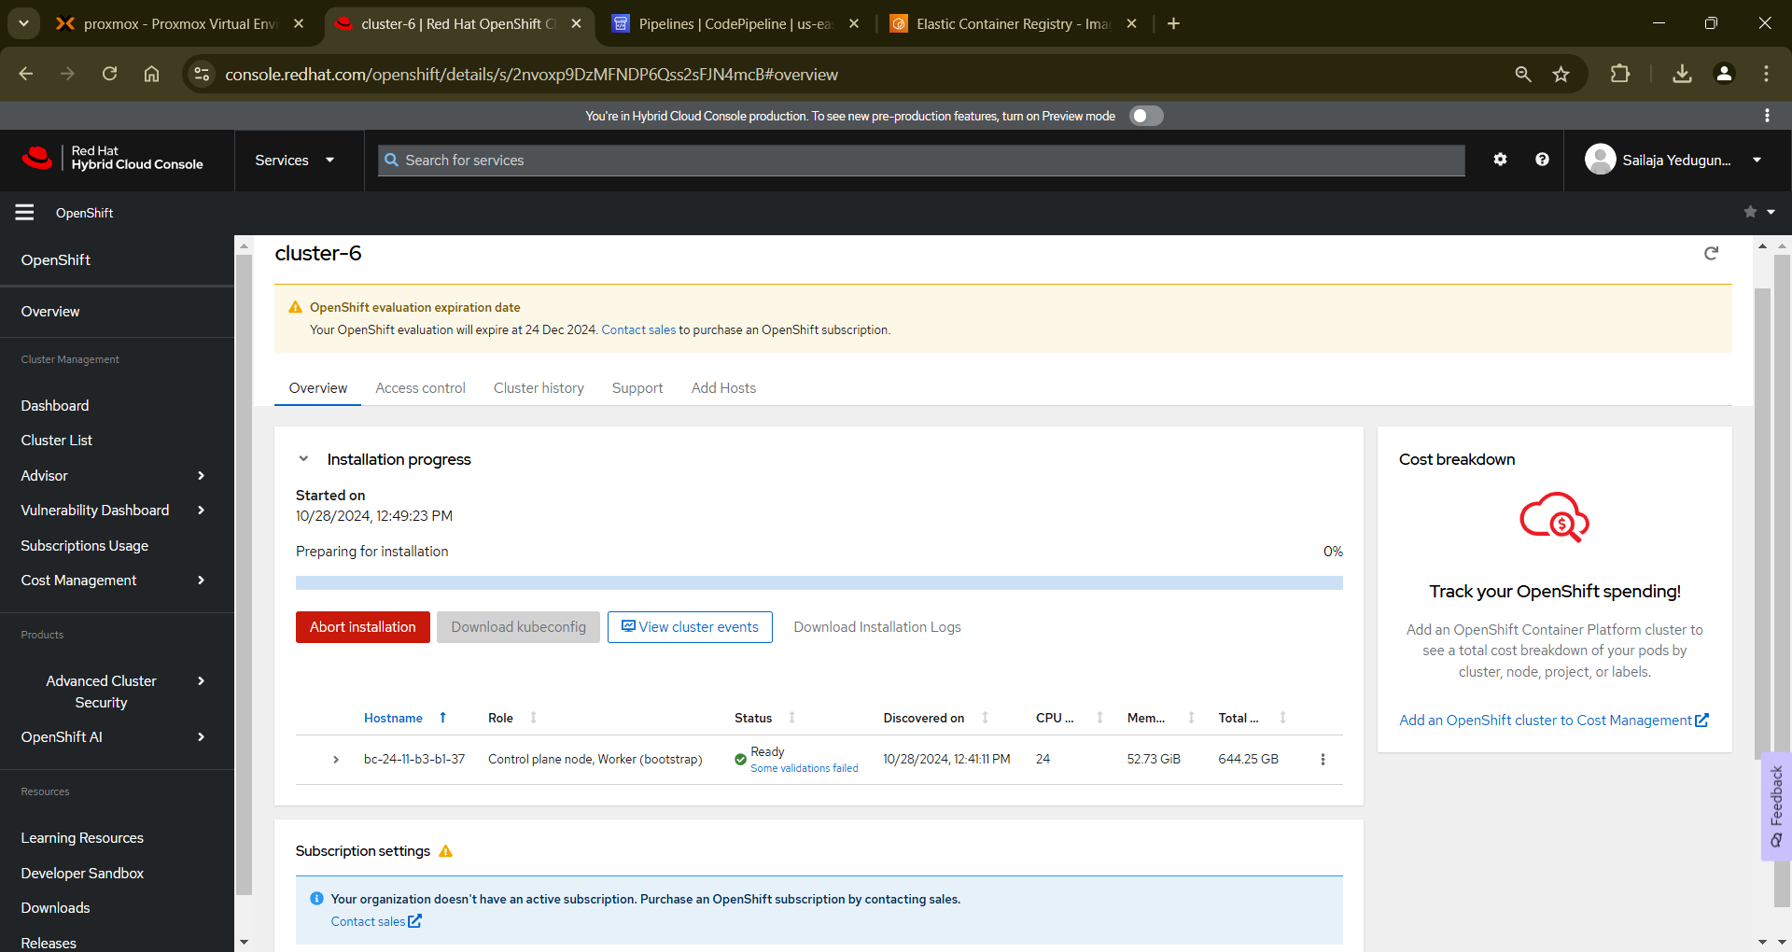

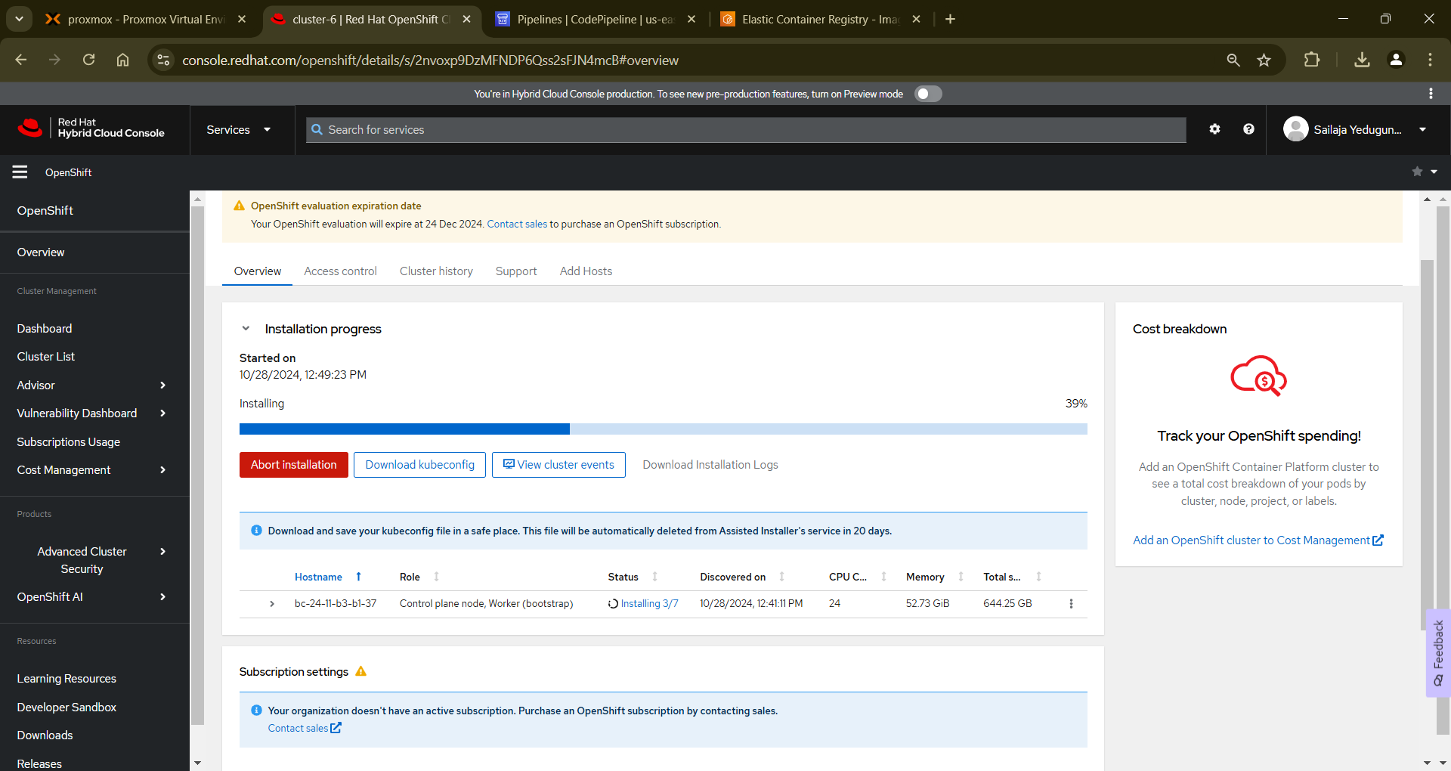

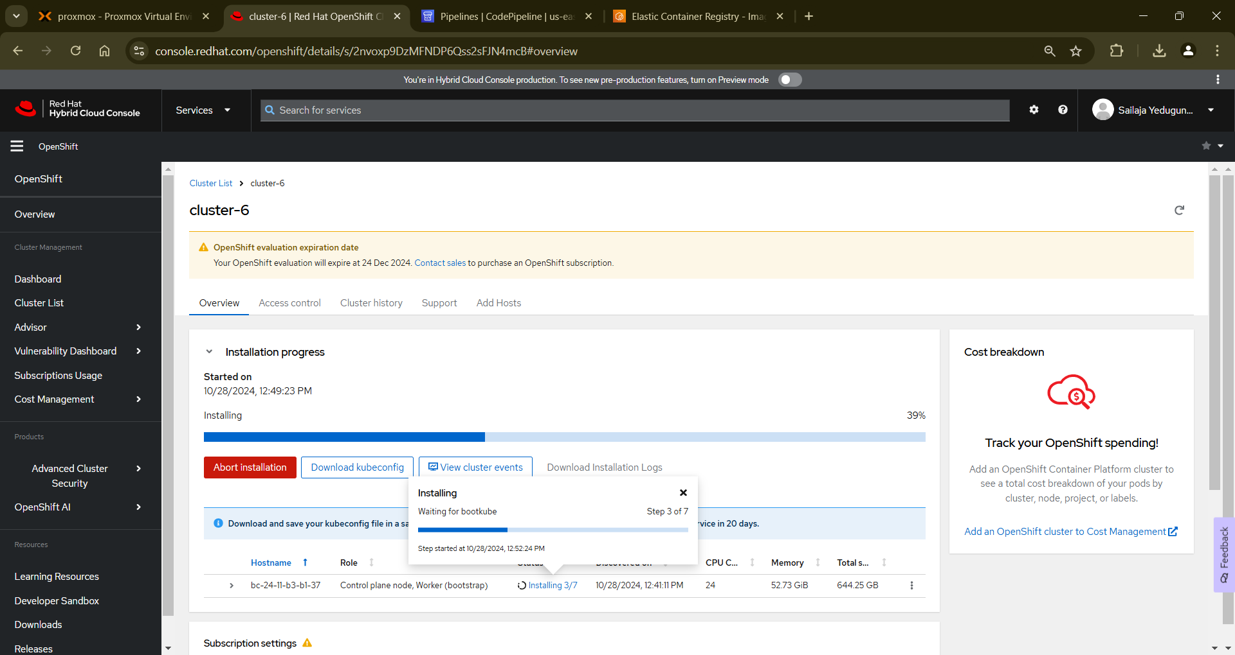

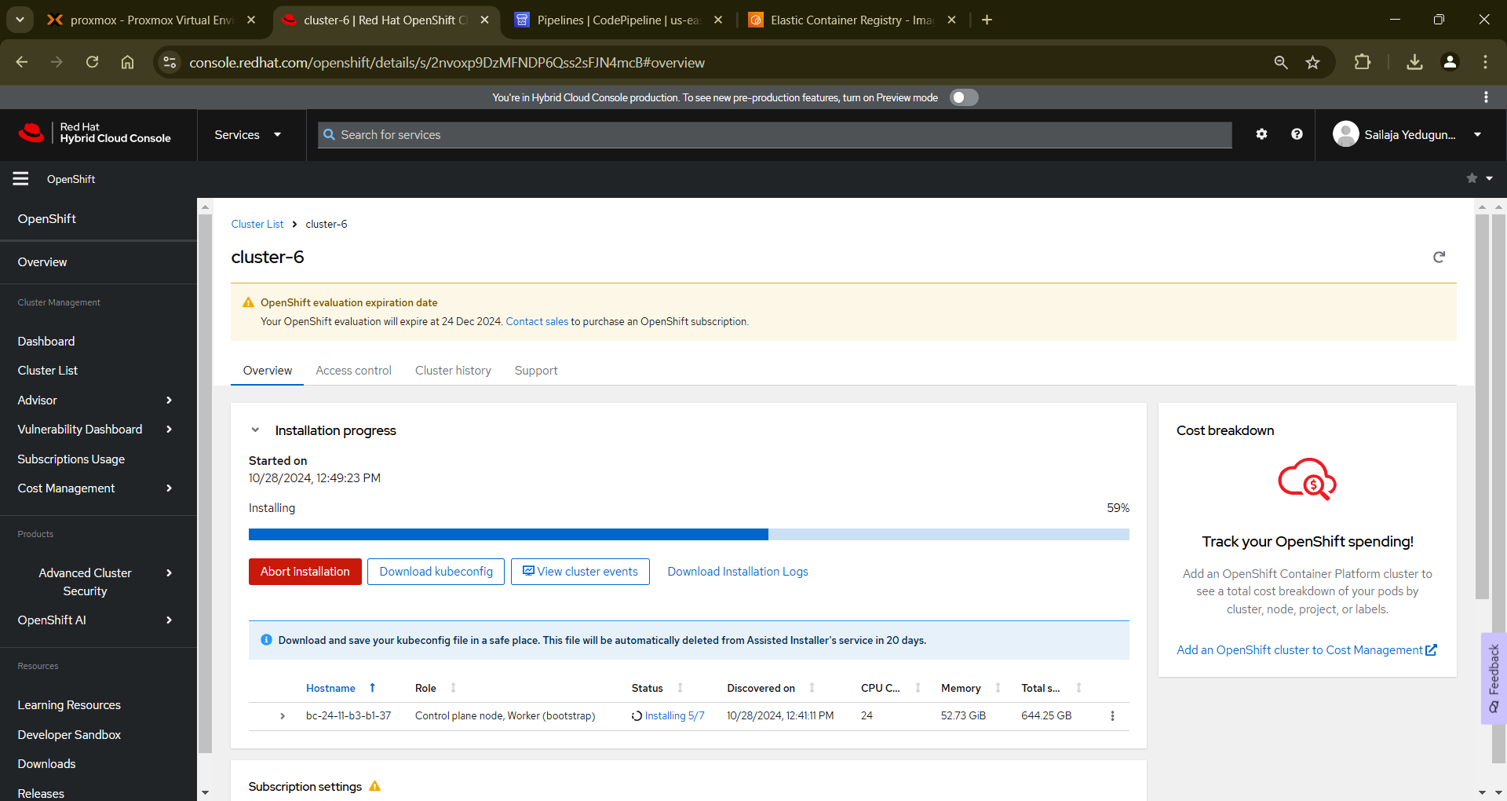

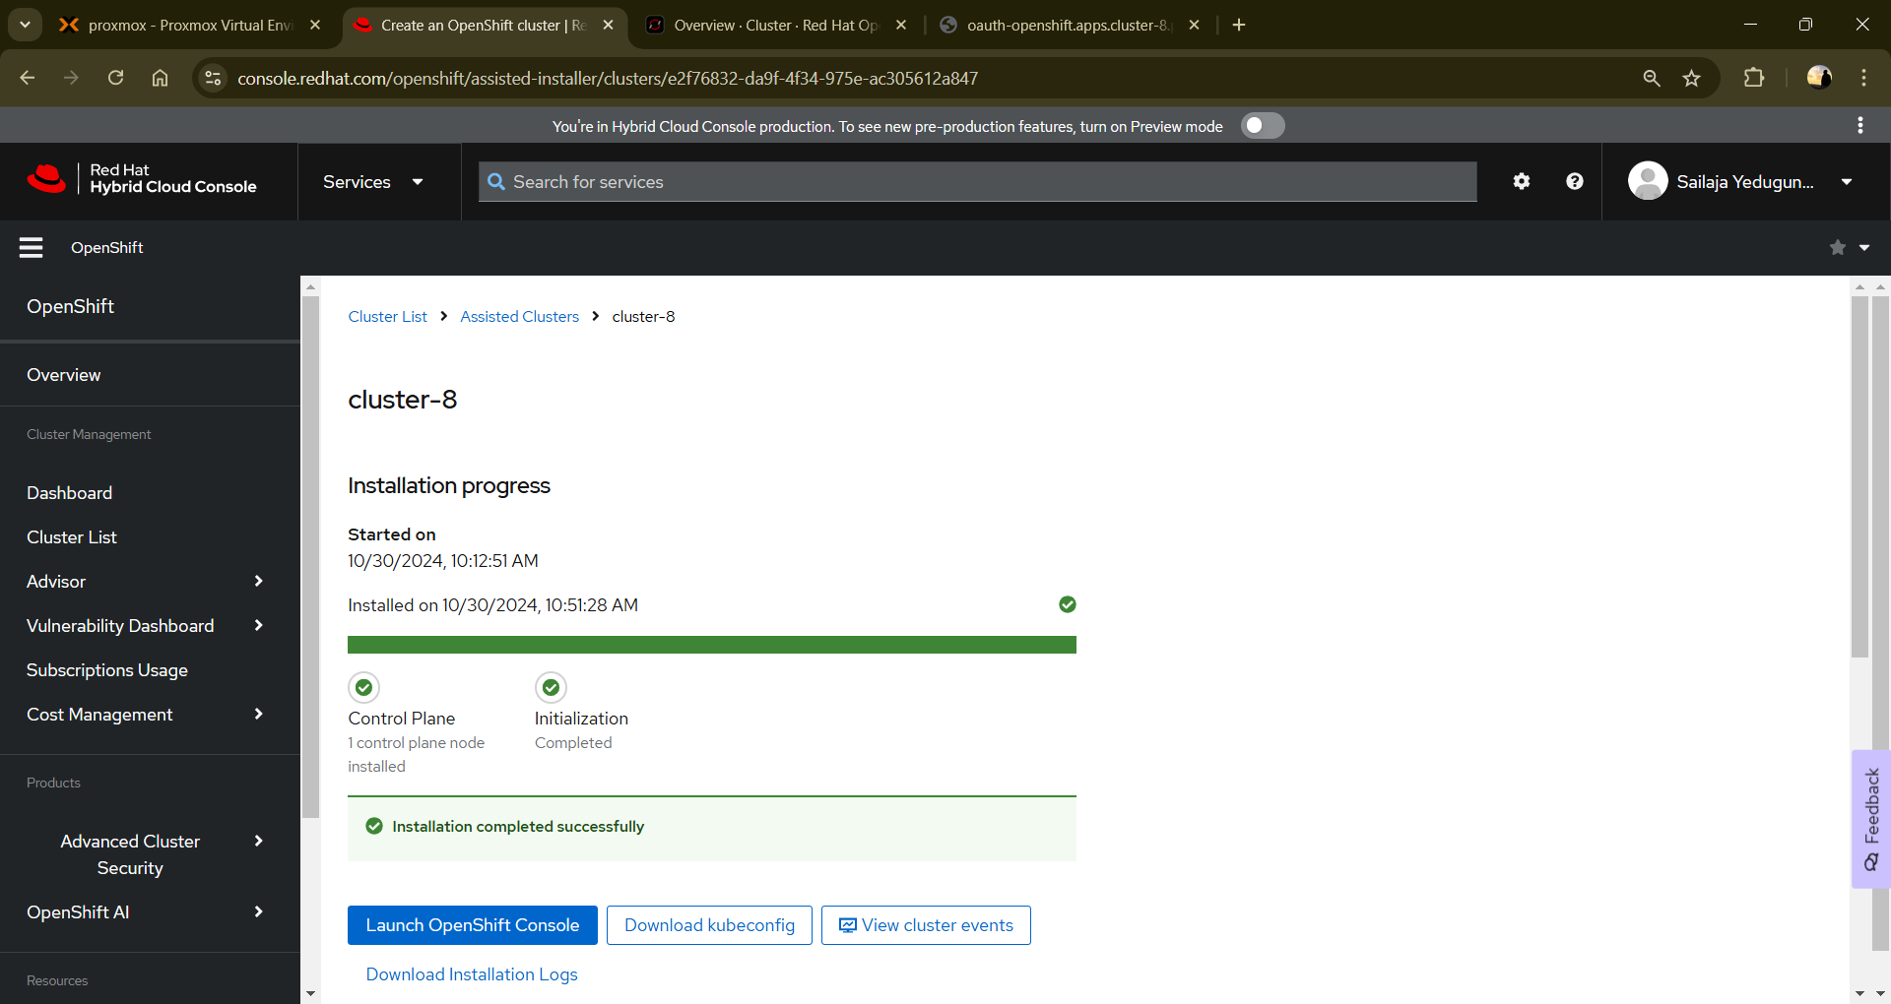

As soon as it gets completed copy the hosts records that you need to update in your hosts file

Add those records in your hosts file in Windows

Now, Launch the console using the link available in the dashboard and use the credentials available



This is how it looks when you launch the console after entering the credentials

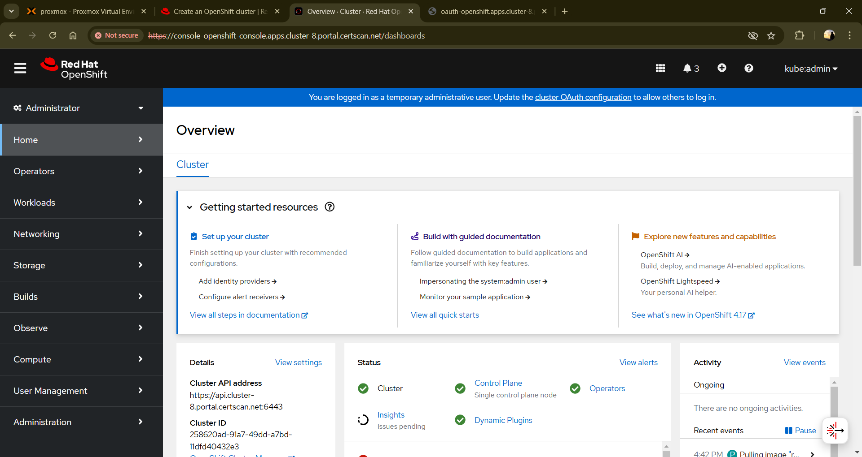

Suggestion: Don’t use haproxy ingress controller as Openshift Kubernetes platform by default provides/uses its built-in haproxy ingress controller. So just deploy ingress rules yaml and secret and make sure you have added tls certificate in the tls section in ingress rules file.